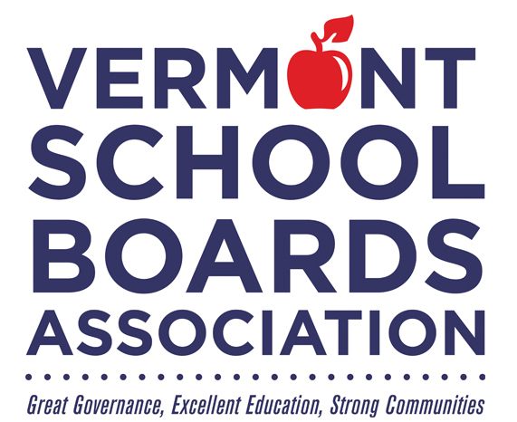

School Board Appreciation Month
February 2026

Honoring

_______________________________________________

For commitment to public education and
continued service to Vermont's students.

